ANNUAL REPORT
2017–2018

It’s all thanks to you.
During difficult times, having a strong community is key. We are encouraged by the unwavering support received from individuals from all walks of life who contribute so much.

Hunger plays out in many forms, sometimes overtly and sometimes subtly and privately. It plays out quietly in classrooms, as children
try to concentrate in their studies; it plays out unobtrusively on city buses, as a parent travels across town to reach a grocery store with adequate, affordable produce; it plays out in hushed conversations
between parents as they try to stretch stagnant paychecks to cover the growing rent, utilities, car repairs, childcare, medications, and— finally and all too frequently last—food.

This past year, we continued to challenge ourselves, our incredible network of community partners and funders to deeper levels of conversation and action, because we know that where there is hunger there are other critical issues facing families in our shared community.

Your compassion, strong support and generosity continues to be the foundation for a community that cares with a resolve to do more. Together, we are providing food and hope. Together we are joining with other community leaders and change-makers committed to addressing hunger right in our community, and ensuring we do so with by maintaining the dignity of children and families who depend on us 52 weeks a year.

As we look back on all that you have made possible this year, we thank you for your confidence in our leadership and ask that you continue to stand with us as we help ensure no child in our community will worry about how they will be fed.

Krista Wright Lena Bassford
Board Chair Executive Director

OUR MISSION:
Providing packages of healthy food for elementary school students from
at-risk, low-income, or disadvantaged homes with little or no food during weekend periods or throughout the summer months.

OUR VISION:
- We believe child and youth hunger is a community responsibility and by working together we can provide a solution-based program that addresses and responds to child hunger in our shared community.
- We believe that alleviating the effects of poverty and hunger strengthens our community, providing children with opportunities to grow, excel and thrive.
- We believe in facilitating programs in a non-stigmatizing, impactful and inclusive manner ensuring dignity of all participants.
- We believe in collaborative partnerships with volunteers, community members, schools, businesses and funders to collectively support children and families.
- We believe that by maintaining the highest standards, we can ensure positive outcomes for children and their families through leadership, transparency, accountability and diligent stewardship of community resources.

GUIDING PRINCIPLES:
Provide packages of nutritious food for children with little or no access to food during weekend periods or during the summer months;
Focus
on schools located in low-income and marginalized neighbourhoods with poverty rates in excess of 40% to reduce barriers for those most in-need;
Conduct
public education and community-awareness initiatives designed to develop an understanding of child hunger;
Provide
leadership as the primary resource for weekend and summer food distribution for at-risk children engaging community partners;
Maintain a high standard of service through best practices and annual evaluation methods; extensive resources to recruit, train, retain and recognize volunteers to facilitate
Devote
the program.

“Too often we underestimate the power of a touch, a smile, a kind word, a listening ear, an honest compliment, or the smallest act of caring, all of which have the
potential to turn a life around.”
Leo Buscaglia

WEEKEND FOOD PROGRAM: Provides packages of healthy food for children aged 4–14 years with limited or no access to food each weekend. Referrals are received from schools aware of children and families struggling with food security. Volunteers package food each Wednesday and volunteers deliver food to schools each Friday morning. At the school, the food package is quietly tucked into the child’s backpack and when the child arrives home and opens their backpack, a healthy food supply awaits them. 1,625 children served.

SUMMER FOOD PROGRAM: Summer is typically a time for camp, vacations and having fun. For our kids, ensuring they have enough food to eat is their greatest focus. Providing food for these children becomes even more critical, since school snack or breakfast programs are not available during the summer months. We addressed this issue by developing a summer food program, the first of its kind in Canada. The children received a bounty of healthy foods including proteins, dairy, fruits and vegetables, along with a weekly feature recipe card to make a simple nutritious meal. The outpouring of support from our caring community helped to ensure food for 600 children in Hamilton and Halton. Each bin was hand-delivered to the homes of children in need by our amazing volunteer team.

Financial year end 2018
INCOME
Donations & one time grants $804,383
Fundraising $382,316
In kind $ 99,500
Interest income $3,717
Total: $1,286,199

EXPENSE
Program & Volunteer Expense $713,334
Bookkeeping, Audit, Insurance $35,108
Fundraising $30,293
Wages $194,482
Office, Telephone, Equipment $35,359
Printing & Promotion $21,442
Occupancy $37,400
Travel & Mileage $12,448
Amortization $3,838
Bank charges $2,299
Total: $1,086,003* Surplus/(Deficit) $200,196*
*$86591 Deferred Income
* $90,000 provided to Halton for startup costs
Hamilton & Halton

66,000 | Food Packages prepared and delivered
1,750 | children in the weekend food program
600 | children in the summer food program
123 | Schools facilitating programs
100% | Child participants living below the poverty line
$10 | To provide one child with a healthy supply of food for an entire weekend
$400 | To provide food for one child each weekend for an entire school year
$400 | To provide food for one child for the entire summer months
$60,000 | Spent each month bulk purchasing healthy food
$8,000 | Received each month in food donations
25,100 | Volunteer hours provided
$361,000 | Wage savings through volunteer support
92,165 | Kilometers traveled by delivery volunteers
4 | Full-time Staff Equivalent managing both Hamilton and Halton regions

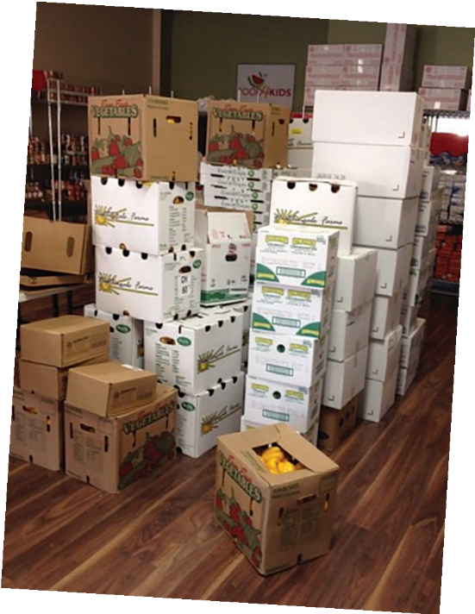

2017–2018 BOARD OF DIRECTORS
Our Team

Executive:
Krista Wright – Chair Tara Dunn – Vice Chair Tony Italiano – Treasurer
Marianne D’Alessandro – Past Chair
Members – Dale Shaughnessy, Tom Flood, Lisa Marie Assenza, Priya Bhatia, Stacey Drohomyrecky, Terri Puckerin

OUR STAFF
Lena Bassford: Executive Director, Hamilton and Halton Regions
Gayle Kabbash: Manager of Community Relations: Oakville, Burlington and Milton
Alex Zaccheo: Administrative Assistant

Program Staff (part-time):
Jennifer Steventon: Burlington/Oakville, Milton
Nancy Phelan: Greater Hamilton
Eva Podoski: Halton Hills

FOOD4KIDS LOCATIONS
Hamilton | Burlington, Oakville, Milton | Halton Hills
405 Whitney Ave | 2258 Mountainside Drive | 2258 Mountainside Drive
Hamilton, ON L8S 2H6 | Burlington, ON L7P 1B7 | Burlington, ON L7P 1B7
905-741-0060 | 905-469-3113 | 416-992-3260
Nancy Phelan | Gayle Kabbash | Eva Podoski
nancy@food4kids.ca | gayle@food4kids.ca Jennifer Steventon  jennifer@food4kids.ca | eva@food4kids.ca

KEEP UP TO DATE BY FOLLOWING US ON
FACEBOOK, TWITTER AND INSTAGRAM!

WE COULD NOT DO THIS WITHOUT YOU.
Thank you to our donors!
Food4Kids is funded through donations or one-time grants. We are gratefulfor the unconditional giving of individuals, groups and businesses entrusting our agency with their donations, knowing the difference their support will make.

To each and every donor, our thanks and assurance, your generous support is literally changing lives within our shared community.

INSPIRATION
$10,000 +

Burlington Foundation Cake & Loaf Bakery
CIBC City of Hamilton
Georgetown Craft Beer Festival GWD Foundation for Kids
Hamilton Firefighters Local 288Assistance Fund IRC
Keller Williams Edge Real Estate Mohawk College Financial Services
Ontario Trillium Foundation Rattlesnake Golf Member Assoc
RBC Foundation SW Region Region of Halton
Tandia The Sprott Foundation
Tim Horton Store Owners Smile Cookie

